**Game Design Document**

**Game Overview**

**Title :** Poulpi Volley (working title)  
**Genre :** Sport Party Game  
**Platform :** PC Standalone + Android&IOS  
**Rating :** PEGI 3  
**Target :** Casual Gamer (aging from 6-30)  
**Release Date :** TBD  
Poulpi Volley is a multiplayer side-view 2D game about squids playing volleyball. The players have to move, jump and smash to control the ball and ground it on the other player’s court.

**Key Selling Points**

• **Couch multiplayer 1v1 or 2v2**• **Physics-based procedurally generated animations**• **Multi-platform**• **Squids playing volleyball**

**Game screen**

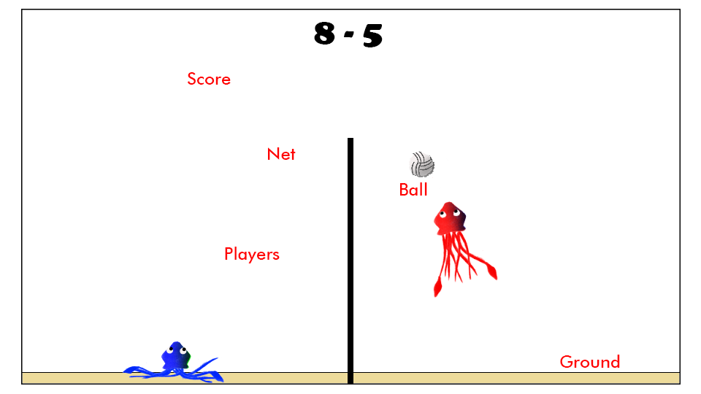

**Goal of the game**

Players score points when the ball hits the ground on the opponent’s side. The match ends when one player or team reaches a previously fixed amount of points.

**Game Rules**

Each match consists of several rounds. At the start of each round, the ball hovers over the ground on the center of one of the player’s court. This player has to “serve” by hitting the ball into the opponent side to start the round. Each player then tries to ground the ball on the opponent's court. They are restricted to their side of the screen and cannot cross the net. Four consecutive contacts with the ball are allowed, touching the ball one time too many results in the other player winning the round. Once the ball hits the ground, the round is ended, a point is granted, and a new round starts.

In 2v2 no consecutive hits are allowed, players have to pass the ball to their teammate. Three passes max are allowed.

**Moves and controls**

|  |  |
| --- | --- |
| Besides moving, **jumping** is the main tool available to the player to control the ball. The player can press the jump button longer to jump higher.  The **super-jump** requires a charging time on the ground, during which the player’s movement is slowed. Once the button is released, the squid propels himself much higher than with a normal jump.    The **dash**, which can only be performed on the ground, allows the player to rapidly gain some ground to reach an otherwise lost ball.  The **smash** is an offensive move that accelerates the ball in a straight line towards the ground. A successful smash is difficult to execute, for the ball has to be in a good position, close and high enough relative to the net. The **super-jump** is the only move that allows the player to get his squid high enough to perform a successful smash without shoving the ball into the net. It’s therefore a high risk, high reward move. The angle at which the ball is thrown depends on the position of the squid relative to the ball when the move is performed. | C:\Users\lenoc\AppData\Local\Microsoft\Windows\INetCache\Content.Word\ConceptArt1b.png |
|  |  |

**MVP (Minimum Viable Product)**

Built for the PC platform

**Wishlist**

• Skins for the squids and ball, as well as different backgrounds to choose from  
• Add an AI for single player mode  
• Add other game modes, like basketball or soccer